LEAFDOC AI
Final Year Project
Session 2022-2026
BS in Software Engineering

Department of Software Engineering
Faculty of Computer Science & Information Technology
The Superior University, Lahore

Type (Nature of project) |  |  |  | [] Development [ ] Research [✓ ] R&D
Area of specialization |  |  |  | BS DATA SCIENCE
 | FYP ID |  |  | BSDS-FYP-F25-001
Project Group Members
Sr.# |  | Reg. # | Student Name |  | Email ID |  | *Signature
(i) |  | SU92-BSDSM-F22-025 | SHARJEEL AHMAD |  | Su92-bsdsm-f22-  025@superior.edu.com
(ii) |  | SU92-BSDSM-F22-006 | SHAHZAIB |  | Su92-bsdsm-f22-  006@superior.edu.com

Plagiarism Free Certificate
This is to certify that, I Sharjeel Ahmad S/D of Maqbool Ahmad, group leader of FYP under registration no at Software Engineering Department, The Superior College, Lahore. I declare that my FYP report is checked by my supervisor.
Date: Name of Group Leader: SHARJEEL AHMAD Signature: _____________
Name of Supervisor: Ms. Asma Abu Bakar
Designation: Lecturer
Signature: ________________

HoD. Dr. Muhammad Aqeel
Signature: _______________

APPROVAL

PROJECT SUPERVISOR
Comments: ___________________________________________________________________
_____________________________________________________________________________

Name: ______________________________
Date: _______________________________ Signature: __________________________

PROJECT MANAGER
Comments: ___________________________________________________________________
_____________________________________________________________________________

Date: _______________________________ Signature: __________________________

HEAD OF THE DEPARTMENT
Comments: ___________________________________________________________________
_____________________________________________________________________________

Date: _______________________________ Signature: __________________________

APPROVAL

Dedication
This paper is for my wonderful parents, who have been providing me love, help, encouragement and support in every possible way throughout my course. We all had a part to play in making it happen and their faith in me, their support made me be determined and persistent in what I wanted. I also dedicate this work to my family whose support and patience has been my strength in this process. It is this motivation to me that helped to overcome challenges and maintain focus towards success. Lastly, I dedicate this work to everyone who has helped me, either directly or indirectly and to all people who have made an effort to benefit knowledge and the society.

Acknowledgements

I would like to thank my advisor, for his helpful criticism, encouraging comments and guidance in the preparation of my thesis. It was important for them to have their knowledge, patience and constant encouragement as they helped me develop this project and learn the material. Further I would like to thank the academic staff and professors for giving me the needed tools, motivation and conducive learning environment that facilitated this study. I would like to express gratitude to my entire family for their unconditional encouragement, understanding and support throughout my entire academic career. I have received support and encouragement from them, so they have helped me to be strong and motivated.

In addition, I would like to express my gratitude to my co-workers and friends for all their help, support and encouragement during difficult times. They were with me, and the trip was no longer so scary and more important. Finally, I would like to thank everybody who was involved in bringing my thesis to fruition, directly or indirectly.

Executive Summary
In this work, the design and testing of a deep learning-engineered apple leaf disease detection system with image classification is being designed. The paper discusses the shortcomings of conventional methods of diagnosing diseases which are normally time-consuming, subjective, and costly to many farmers. The system proposed will aim to provide accurate, timely, and reliable disease diagnosis using the latest developments in the field of Artificial Intelligence (AI) particularly Convolution Neural Networks (CNNs).
A total of 3,171 apple leaf photos were classified as either Healthy, Apple Scab, Black Rot, or Cedar Apple Rust in the data set. The model's generality and robustness were improved by per-training and enhancing the photos. The CNN architecture was chosen after considering the various deep learning algorithms as it has shown to be the most effective for image classification. The accuracy of the model was around 99%, and the accuracy of the individual illnesses detection was up to 98% using TensorFlow and Keras.
To close the research-practical gap, the trained model was implemented with FastAPI, allowing to make real-time predictions via a web-based interface written in React.js. It enables users to post images of leaves and get a real-time diagnosis, which is easy to use and accessible to non-technical users and especially farmers. These findings point to the potential usefulness of deep learning-based systems for enhancing the precision and efficacy of plant disease diagnosis.. Although it is highly performing, the system has a limitation in the scope of data set and variability of the environment. It is suggested to continue working on it in the future to increase the data set, add more crops and diseases, and combine real-time sources of information.
On the whole, this research adds to the development of smart agriculture by offering an effective and scalable solution to detect early diseases and assist in better managing crops and food security.
On the whole, this research adds to the development of smart agriculture by offering an effective and scalable solution to detect early diseases and assist in better managing crops and food security.

Table of Contents
LEAFDOC AI i
Plagiarism Free Certificate ii
Plagiarism Free Certificate iii
Dedication v
Acknowledgements vi
Executive Summary vii
Table of Contents viii
List of Figures x
List of Tables xii
List of Abbreviations xiii
Abstract xv
Chapter 1: INTRODUCTION 1
1.1 Background and Motivation 1
1.1.1 Background of Study 1
1.1.2 Traditional Disease Diagnosis and Its Limitations 2
1.1.3 Advances in Deep Learning for Plant Disease Detection 3
1.1.4 Need for Real-World Deployment of Deep Learning Models 4
1.1.5 Role of FastAPI in Model Deployment 5
1.2 Problem Statement 6
1.3 Objectives 6
1.4 Research Questions 7
1.5 Scope and Limitations 7
1.6 Thesis Organization 7
Chapter 2: Literature Review 8
2.1 Introduction 8
2.2 Review of Techniques 9
2.3 Review of Deep Learning Approaches 10
2.4 Review of Datasets & Benchmarks 11
2.5 Existing Tools & Frameworks 12
2.6 Research Gap 13
2.7 Summary of Literature 13
Chapter 3: Problem Definition and Methodology 16
3.1 Dataset Description 16
3.1.1 Working of Convolutional Neural Network 16
3.2 Data Preprocessing 20
3.2.1 Image Augmentation 20
Chapter 4: Design and Architecture 21
4.1 Model Architecture 21
4.2 Model Development and Deployment 22
4.3 Experimental Setup 22
Chapter 5: Implementation 23
Chapter 6: Result and Discussion 25
6.1 Model Training and Validation 25
6.1.1 The RELU and pooling layers in a CNN 25
6.2 Performance Evaluation and Comparison 26
6.3 Visual Analysis and System Outputs 26
6.3.1 The CNN graph displaying the RELU 27
Chapter 7: CONCLUSION AND FUTURE WORK 30
7.1 Summary of Findings 30
7.2 Contributions of the Study 30
7.3 Limitations 30
7.4 Future Research Recommendation 30
References 31

List of Figures

1.1: Apple leaf diseases and recognition 2
1.2: Traditional Methods 3
1.3: Crop Disease detection by using machinery techniques 4
1.4: A graphical representation of the system architecture 5
1.5: Network structure of Mobile Net-MFS 5
3.1: Convolutional neural network (CNN) phase-1 in action 17
3.2: Neural Network Phase 2 Operation 17
3.3: Convolutional neural network (CNN) phase 3 behavior……………………….…………..18
3.4: Working of CNN phase-4 18
3.5: Working of CNN phase-5 19
3.6: Working of CNN phase-6 19
4.1: Typical architecture of CNN 21
6.1: Relational and pooling layer graphical behavior ………………………………………………26
6.2: Visual depiction of RELU 27
6.3: Apple Scab picture output shown on the browser 27
6.4:Black root picture output shown in the browser 28
6.5: Pictures of healthy leaves shown on a web browser 28

List of Tables
2.1: Summary of Literature ………………………………………………………………………………………………………. 13

List of Abbreviations
Abbreviation | Full Form
AI | Artificial Intelligence
API | Application Programming Interface
CNN | Convolutional Neural Network
DL | Deep Learning
ML | Machine Learning
ReLU | Rectified Linear Unit
UI | User Interface
UX | User Experience
RGB | Red Green Blue
HTTP | HyperText Transfer Protocol
JSON | JavaScript Object Notation
Keras | High-level Neural Network API
TensorFlow | Open-source Deep Learning Framework
VGG16 | Visual Geometry Group 16-layer Network
ResNet | Residual Neural Network
FastAPI | Fast Application Programming Interface Framework
IDE | Integrated Development Environment
GPU | Graphics Processing Unit
CPU | Central Processing Unit
F1-score | Harmonic Mean of Precision and Recall

Abstract
Timely detection of plant diseases is an important technique to increase production and food security. Leaf diseases in apples, if not detected early, can lead to a decline in yield and quality. Conventional diagnosis involves visual inspection, which can be slow, unreliable, and requires expert knowledge, which may not always be available. This makes it difficult to achieve timely and accurate diagnosis, especially in resource-constrained or large plantations.
Here, we present an automated deep learning and image classification approach for the detection of apple leaf disease. The system used a Convolutional Neural Network (CNN) to categorize leaf images into four classes: Healthy, Apple Scab, Black Rot and Cedar Apple Rust.
Training data consisting of 3,171 images were used to train the model, using techniques such as reprocessing and data augmentation to improve accuracy and robustness. The accuracy of the system was 99% when it was used to classify leaves. In order to use it easily, the model was implemented in a Fast API and web-based system, where it can predict real-time images by simply uploading an image. This system is much faster, more accurate and easy to use than the traditional and previous machine learning techniques. The present system is able to classify 4 types of diseases using image data, but is scalable and feasible to agricultural applications. Future research will focus on a larger data set, inclusion of environmental conditions, and mobile-based apps to improve functionality.

Chapter 1: Introduction

1.1 Background and Motivation

1.1.1 Background of Study
One of the most important contributors to global food security is the agricultural sector, which is also one of the most vulnerable to the consequences of plant diseases. Apples are fruit crops of great economic importance that are grown within the global scale; hence they are very important to the farmers and agricultural markets. Nonetheless, apple trees also tend to fall prey to several illnesses including Apple Scab, Black Rot and Cedar Apple Rust [1]. Such diseases do not only ruin the fruits and leaves but also leave an impressive drop in the general yield in case they are not prevented on time. Conventionally, the process of disease identification is based on the manual examination of the farmers, which is heavily relying on the experience, and the inconsistency of the results is possible because of the environmental conditions, variations in the plants, and human error. With an increased size of farms, there are difficulties with manual inspection, which is slow, hard, and inaccurate [2].
Agriculture continues to be one of the strongest foundations of global food production, economic development, and employment generation. Among the wide range of commercially valuable fruit crops cultivated worldwide, the apple (Malus domestica) holds immense importance because of its widespread consumption, nutritional benefits, and strong commercial demand [3]. Apples are cultivated in many countries including China, the United States, Turkey, India and some European countries and play a vital role in the local and international markets. Although of economic importance, apple crop production is very sensitive to environmental fluctuations, insect pests, and most of all foliar diseases. Apple leaf diseases also have an impact on the health of the tree, orchard productivity, fruit quality and orchard sustainability. [4].
The first and most obvious signs of problems in apple trees are leaf diseases. Farmers face significant challenges from diseases that can easily spread across orchards, often at high speed, particularly in good weather such as Apple Scab, Black Rot, Cedar Apple Rust, Alternaria leaf blotch and Powdery Mildew. Such diseases affect the photosynthetic ability of leaves, decreasing tree vigor and fruit production[5].
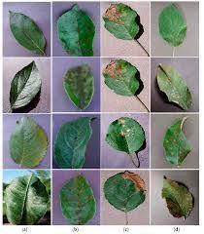

Figure 1.1: Apple leaf diseases and recognition
In extreme instances leaf diseases can cause defoliation, smaller fruit, misshapen fruit, fruit blemishes which can affect market value and even long-term tree decline. The losses from these diseases vary from moderate yield losses to complete crop failure depending on the type of disease, stage of detection and management practices used. There is an immediate need for fast, accurate and timely disease diagnosis technologies to assist the growers in reducing loss and maintaining orchard health[6].

1.1.2 Traditional Disease Diagnosis and Its Limitations

Traditionally, apple leaf disease diagnosis depended on the manual approaches of field scouting and visual (farmer, expert, and plant pathologist) identification. Evaluation by experts can be accurate but may not be available to farmers in remote or resource-poor environments[8. Furthermore, manual inspection requires a lot of time and effort and is susceptible to human interpretation, leading to the risk of misdiagnosis. Traditional diagnosis is further complicated by the accuracy of diagnosis made by environmental factors, early stage symptoms that mimic nutrient deficiencies, and symptom unevenness across the orchard. Lab-based diagnostic tools are more accurate, but they are expensive, require special equipment and are time consuming to process for routine field-based applications.][9].

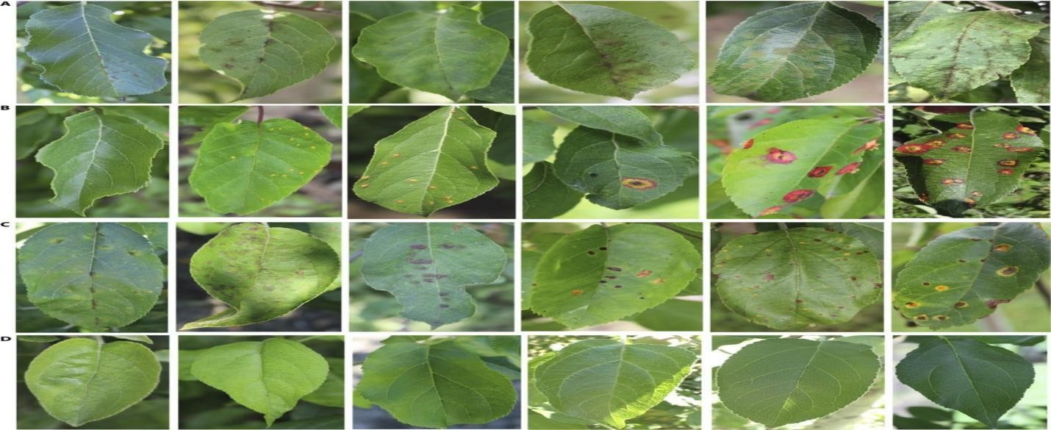

Figure 1.2: Traditional Methods
The constraints of manual and laboratory diagnosis highlight the importance of automated diagnosis methods that can rapidly and accurately detect disease. Farmers should be equipped with technologies that can support them to understand and intervene in the field during real time, as climatic conditions are still changing, and apple production keeps increasing globally. Delayed and incorrect diagnosis can cause diseases to escalate, result in wasteful pesticide usage and cause economic losses [10].

1.1.3 Advances in Deep Learning for Plant Disease Detection
AI and computer vision technology have given rise to a new field called deep learning, which could revolutionize agricultural disease control. Deep learning models, and CNNs especially, have shown remarkable performance in image classification tasks due to their ability to learn itself from images in a hierarchical manner. This obviates the need for manually drawn features which can be inadequate to represent the differing characteristics of one disease from another[11].

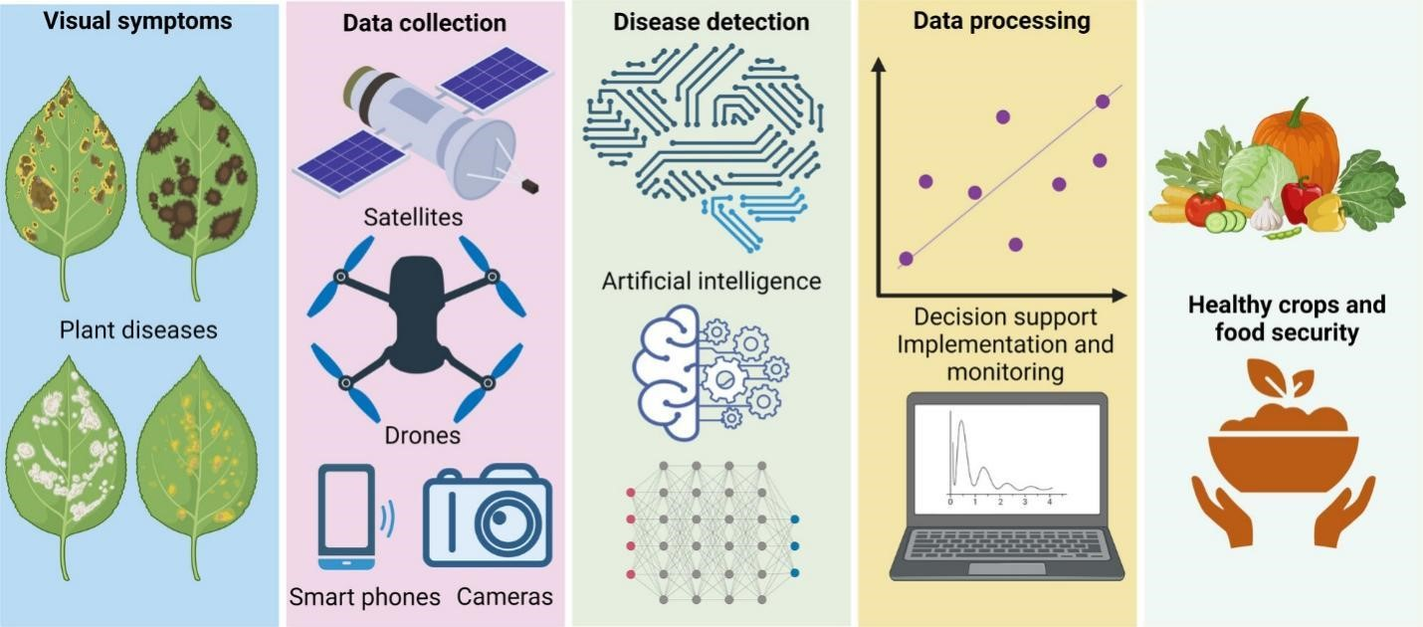

Figure 1.3: Crop Disease detection by using machinery techniques
The CNN approach for diagnosis of apple leaf diseases is an excellent concept as it can detect changes in leaf texture, color, shape and lesion patterns. Research results [12,13]. show that models based on deep learning trained on a vast number of plant leaf images often outperform classic machine learning models in terms of accuracy. This strength of deep learning allows for the correct identification of diseases despite changes in lighting conditions, angle, direction of leaves and background. These models can be trained with enough data to generalize well to new pictures, and thus can be used in various practical agricultural tasks.

1.1.4 Need for Real-World Deployment of Deep Learning Models
High performance deep learning models are available in the academic and experimental environments but a key challenge is how to get these models to be useful for farmers. We have a long way to go before many of these trained models can be deployed in the real world—mainly due to the need for specialized software environments, coding knowledge, or advanced computational resources. These are resources that most farmers and field technicians do not have, which gap exists between the technological advances and implementation [14].

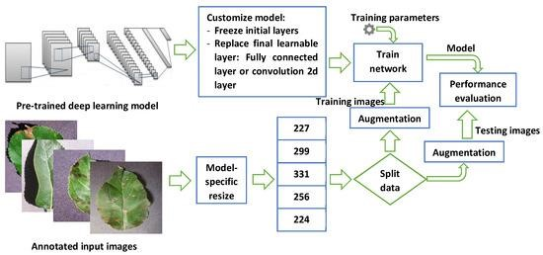

Figure 1.4: A graphical representation of the system architecture.
To overcome this, deployment frameworks and web-based technologies have come into existence. They enable trained models to be embedded in easily accessible platforms and interact with users via intuitive interfaces. The systems remove the need for technical expertise and enable a farmer to upload an image of a leaf and get an instant prediction of the disease. In-situ diagnostic devices can have a great beneficial impact on agricultural decision making, minimise crop loss and better manage agricultural operations [15].

1.1.5 Role of FastAPI in Model Deployment
Although there are some successful deep learning models at academic and experimental settings, bringing these models to the farmers is the crucial barrier to overcome.With FastAPI, developers can create an API that can be easily integrated with a backend service that is based on a trained deep learning model. Using this API, a user can upload an image, and the API will provide an almost instant prediction back to the user [16].
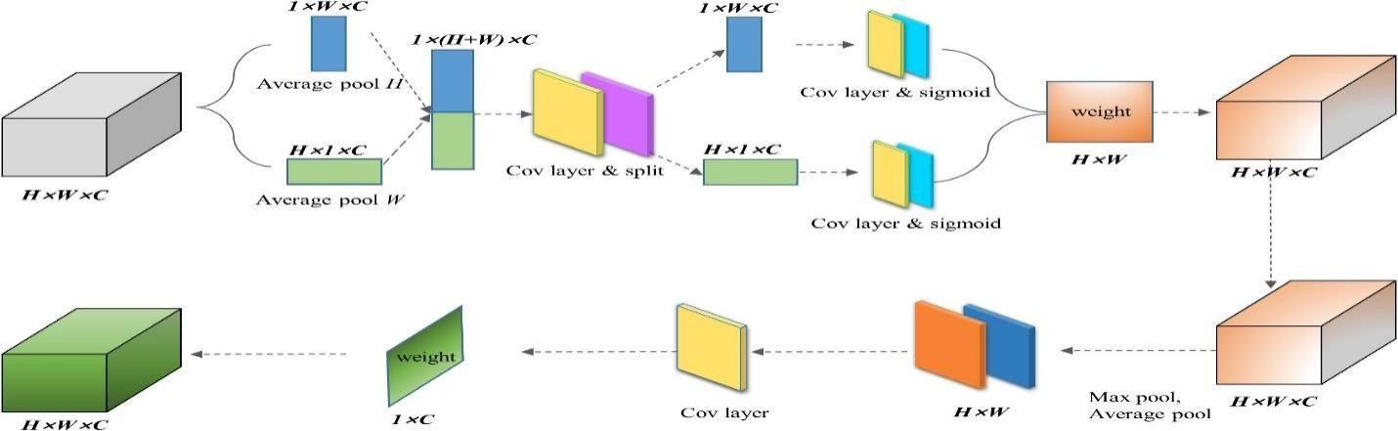

Figure 1.5: Network structure of MobileNet-MFS.
The framework also offers automatically generated documentation, which makes the system understandable and easy-to-use for developers and users [42-45] With FastAPI, you can create a lightweight, portable, and scalable system that can be deployed to a local server, cloud platform, or even a mobile device that is connected to the internet. When applied to agriculture, FastAPI can help turn this deep learning research into a tangible tool that can be used by farmers in the field, making the performance of the model tangible..
Disease detection is a more viable and precise answer, particularly with the development of Artificial Intelligence, and more specifically, Deep Learning. Convolutional Neural Networks (CNNs) have the ability of detecting complex images, and thus they can be used to detect signs of disease on the apple leaf photographs [17]. The current AI systems provide a chance in creating intelligent, fast, and user-friendly disease detection systems. This project will provide assistance to farmers through the combination of deep learning models and FastAPI backend and a web interface based on React.js, whereby leaf images uploaded can be classified in real-time concerning their diseases[31].

1.2 Problem Statement
Farmers tend to have problems detecting diseases at early stages since the symptoms can be similar or they can be latent. Manual investigations are experienced with professionalism and might lead to a delay in the realization, which eventually decreases crop yields. Lack of an easy, convenient, and dependable digital tool also contributes to the lack of timely decisionmaking. Hence, this directly predetermines the necessity of automated system that will be able to provide the classification of the diseases affecting apple leaves and use image data to do it. The given project fulfills that requirement by creating a model that can detect apple diseases in a short amount of time and with high accuracy [3-5].

1.3 Objectives
The main goal of this research is to design a deep learning–based image classification system that will enable the detection of various apple leaf diseases. The goals of this project are:
- Create a deep learning model for classifying various diseases in apple leaves
- Choose a well-cured data set and perform preprocessing and augmentation.
- Train and evaluate a CNN classifier with the goal of achieving high accuracy (>95%).
- Deploy the trained model using FastAPI. Develop a simple and responsive React.js web application for end users.

1.4 Research Questions
- Can deep learning models effectively detect apple leaf diseases using image-based data?
- How does the application of transfer learning influence or improve the accuracy of apple leaf disease classification?
- How can a FastAPI-based backend be utilized to deploy a trained deep learning model for real-time prediction?
- How can a React-based frontend be designed to create an accessible and user-friendly interface for real-time apple leaf disease detection?

1.5 Scope and Limitations
In this study, particular attention is paid to four types of apple leaf health conditions, such as healthy, Apple Scab, Black Rot, and Cedar Apple Rust. In the project, it is planned to develop a CNN model, deploy it with FastAPI, and have a complete prediction-based web interface. Nevertheless, it does not combine live camera footage and drone-based surveillance and uses the dataset images instead of live field data. In addition, the model can only cover the four classes and might not be applicable to other diseases outside the dataset.

1.6 Thesis Organization
The project procedure is explained in detail in this thesis. In Chapter 1, the study's rationale and context are laid forth. The overview of relevant literature, drawing attention to earlier studies and their theoretical underpinnings, is presented in Chapter 2. Database preparation, model architecture, and deployment are all covered in Chapter 3 of the technique. Chapter 5 offers a conclusion and recommendations for future study, whereas Chapter 4 is devoted to outcomes and assessment.

Chapter 2: Literature Review

2.1 Introduction

Machine Learning (ML) and Deep Learning (DL) have been of immense interest in plant disease detection within the past years owing to the development of image processing and artificial intelligence [6]. The same methodologies that can be applied to medical imaging for early diagnosis have been applied here, helping to diagnose the disease with greater accuracy and automatically, in agricultural crops. Convolutional Neural Networks (CNNs) have been able to achieve outstanding performance in the analysis of plant leaves images and the categorization of healthy and diseased ones. The existing studies reviewed and some techniques used to identify the leaf disease is presented in this chapter as well as the gaps that can be filled in this project [29].
One of the significant developments in agricultural technology is the shift from manual to automated plant disease assessment techniques in the form of digital solutions. Bock et al. noted that the traditional approach for estimating severity of plant diseases has been to visually assess the disease, but this method of assessment is subject to various factors including subjectivity, inconsistent lighting, and evaluator bias. They reported on the trend of sensor-based and automated image-analysis methods to increase accuracy and reduce human error, which developed the groundwork for automated detection systems using deep learning technologies that can be used in the identification of apple leaf disease . It highlights the need for reliable repeatable and scalable methods, which directly relates to the development of automated apple disease detection tools based on CNNs [1]. It highlights the need for reliable repeatable and scalable methods, which directly relates to the development of automated apple disease detection tools based on CNNs.

Zhao and Xie also expertly summarized the uses of deep learning in agricultural product analysis and its ability to identify subtle structural patterns and anomalies that are difficult to notice by hand [2]]. According to their study, convolutional architectures are a good promise for leaf disease classification in plants, as they are considered to be good at recognizing key visual information in images. They are especially useful for the detection of apple leaf disease, where the variation in texture, lesions and color need to be detected accurately. Deep learning models, when integrated into real-time agri-systems, can greatly improve disease detection accuracy in agricultural crops of various types, wrote the authors .

2.2 Review of Techniques
AI has been making a significant impact in the field of disease detection, not just in agriculture. Tanwar et al. proved it by developing an Artificial Intelligence (AI)-based detection system for COVID-19, which is able to analyze complex medical data using the deep learning models [3]. Their research is human health related but the concepts of fast detection using images and automatic classification are well transferable to plant pathology. They found that the AI systems are reliable when trained using a variety of sets of images and are found to be reliable when applied to classification of images, such as the screening of apple leaf diseases that are image-based problems in agriculture [38].

Ahmed et al. [4] provided a comprehensive review on the progress of deep learning modelling approaches, their performance, flexibility and their problems for real world applications. Their results indicate that deep learning has emerged as a key technique for tackling classification, prediction and segmentation problems in complex domains. Optimization of the model, computational limitations, and deployment issues are discussed, which play a critical role in building the backend based on the Fast API for real-time disease detection. This research paves the way for the integration of deep learning and API-based deployment for strong field deployment in agriculture [4].

Deep CNNs have demonstrated remarkable diagnostic power in disciplines other than plant sciences, like ophthalmology. Brown et al. used CNN to identify ROP, and showed the ability of deep learning to detect fine-grained visual anomalies in medical images [5]. Their findings also showed high values of sensitivity and specificity, which shows the capability of CNNs in understanding various visual symptoms. These results are similar to those obtained for the detection of an apple leaf disease where only slight variations exist between diseases and feature extraction is a crucial task [29].

Transfer learning has proven itself a highly effective technique for image classification problems, particularly when the data sets are small or unbalanced. To address the challenge of limited training data, transfer learning was applied to enhance the performance in COVID-19 CT scan recognition, where pre-trained networks were used to augment the limited training sets, showed Li et al. [6]. Their work confirms the value of leveraging pre-trained CNN models like ResNet or VGG for the classification of apple leaf diseases, particularly as agricultural datasets may not be large enough to support training extensive CNNs from the ground up.

In the clinical setting, AI has also been found to have potential in predictive modelling. Abdulaal et al. explored the application of machine learning in the COVID-19 prognosis and demonstrated that a trained machine learning model can predict accurately from the diagnostic data [7]. While not a plant disease classification, the methods and deployment processes described by the authors give insight into development of AI systems that will be reliable in use in real-world conditions. Their results are encouraging the demand for deployable, API-driven systems such as Fast API, which will enable such models.
Specifically, in agriculture, Sow et al. investigated AI's ability to improve input utilization efficiency such as nutrient use, weed management and water management [8]. Their research emphasizes the increasing importance of intelligent systems in the field of modern agriculture decisions making. Both the authors and the apple leaf disease detection systems would like to see the reduction of human error and optimization of productivity, which are the two goals of automated products. The insights reveal the potential of AI-based detection systems in promoting healthier cropping practices and minimizing yield losses.

2.3 Review of Deep Learning Approaches

Pappula-Reddy et al. highlighted the use of AI models in crop breeding and predicting traits, showing how machine learning improves agricultural decision-making processes [9]. Their results support the concept that deep learning can be applied in many areas of agriculture other than disease detection. The work demonstrated how machine learning systems could be used to predict plant health, highlighting the potential of implementing similar predictive systems for the identification of apple leaf diseases and their use for early diagnosis. Machine learning has been an essential technology for pattern recognition tasks for a long time [9].

The early developments of machine learning are described in the seminal text by Mitchell and a conceptual basis for the supervised classification approaches are provided. This foundational study has been the basis of the key principles which are still at the heart of current deep learning models. These principles provide an understanding of the evolution of modern CNN-based systems for apple leaf disease detection [10].

The breakthrough ResNet paper by He et al. [11]] solved the vanishing gradient problem and offered the ability of training extremely deep networks. ResNet changed the image classification game and accuracy was boosted on datasets. This architecture is especially significant for apple leaf disease detection as deep residual models are frequently adopted in transfer learning pipelines for high accuracy plant disease classification. The paper offers a theoretical background for the selection of state-of-the-art architectures for plant disease classification.

2.4 Review of Datasets & Benchmarks

Ferentinos demonstrated one of the most extensive deep learning approaches for plant disease diagnosis with a range of CNN-based architectures that achieve high accuracy in plant leaf image classification . His results show that CNNs have the potential to be successful in agriculture and the importance of training powerful models based on large labeled datasets.The outcomes confirm the need to use deep learning in the classification of apple leaf diseases [13].

However, Wang explained that there are technological challenges that hinder the use of real-time agricultural AI systems, as the accuracy of the models in research environments is typically high but their deployment in the field is constrained [14].. Some of his work addresses challenges such as computational constraints, the user-friendliness of deployment frameworks and the integration of AI models with farm-specific tools. The implications of these findings are significant for deployment with Fast API, as they underscore the need for model development to be aligned with the real-world accessibility of the models.

Sahu et al. in their thorough study on different machine learning techniques employed in agricultural application of banana crop focused on disease detection, prediction and classification. [15].. Machine learning has been proven to solve agricultural problems effectively in their research. They concluded that their results were also in line with the goals of the apple leaf disease detection systems, which further highlights the importance of supervised learning models in the monitoring of crop health. Shorten and Khoshgoftaar examined methods for data augmentation from images, which were found to be useful in enhancing deep learning model generalization and in minimizing overfitting[16]. In many cases, leaf data is not sufficiently diverse in lighting, orientation, or disease severity for disease detection, particularly in plant tasks, and augmenting the data is necessary. Their observations directly contribute to the training of data for leaf disease classification of apples.

Hosni et al. investigated ensemble classification techniques and the advantages in performance on medical datasets [17].. Ensemble methods have the potential to increase the reliability of plant disease detection systems by integrating multiple models to gain better prediction accuracy and robustness. The study suggests that ensemble/hybrid methods might improve the classifiers for apple leaf disease. Noronha et al. explored the use of deep learning for dermatological disease detection and achieved a high classification accuracy using the CNN model on skin lesion images [18].. According to their analysis, deep learning is very successful in texture-dependent classification problems. This means that their findings have implications for the detection of apple leaf disease, since the texture, color variation and shape distortions of lesions are important characteristics.

2.5 Existing Tools & Frameworks
Data augmentation was also discussed by Shorten et al., who explain the benefits of synthetic data for deep learning for text classification [19]. While the data type of text is different from that of images, the idea of increasing training sets is applicable. Their results highlight the need for augmentation for producing apple leaf disease detection models, particularly in the case of small image sets. Araujo et al., discuss the use of machine learning for toxicity outcome prediction for cancer therapy and the importance of systematic analysis to guide the selection and evaluation of the model [20]. Although their focus is healthcare, their method can be used to rigorously evaluate models, which is key for agricultural applications. The findings from their study are a reminder that benchmarking and model validation are essential during the building of a real-time system like an apple disease detector built with FastAPI.
Vengadesh et al. studied the trends in AI research through bibliometric analysis to illustrate the increasing number of AI-related studies in various fields[21]. According to their findings, there is a clear rise at the use of AI in real-life problems. This trend is still continuing with deep learning being adopted in agriculture and its potential in disease detection and deployment-based systems. Kumar and Kukreja studied the deep learning models used for wheat disease classification and found that CNNs always gives better results than traditional classifiers of features [22]. Their results corroborate the goal of apple leaf disease classification and make CNNs the best architecture for agricultural disease detection.

Knowledge graph-based approaches have also been found to be useful AI tools. Pi et al. Compared domain-specific knowledge graph applications, and pointed out the value of using knowledge graph in enhancing intelligent decision support [23]. Their results, although not directly pertinent to disease detection, imply possible directions for the incorporation of knowledge-driven reasoning in future agricultural diagnostic systems. Khan et al. performed a scientometric analysis of the image processing applications related to structural defect detection, demonstrating the strength of computer vision techniques in detecting visual anomalies [24]]. Their know-how is applicable to agricultural disease detection, where image-based anomaly identification plays a vital role. This increases the theoretical basis of using image processing and CNN technology in the classification of diseases in apple leaves.
Finally, Altini et al. presented the ability of CNNs in medical image segmentation and classification, showing that deep learning can be used in conjunction with clustering methods to enhance the detection accuracy [25]]. Their fusion approach sheds light on the potential opportunity for fusion of various algorithms for plant disease detection. Their study demonstrates the viability of CNN models for accurate classification of leaf diseases and provides some insights into the development of hybrid diagnostic systems.

2.6 Research Gap
There are many examples that employ CNNs and transfer learning to get a high accuracy for disease classification, but there are still a lot of unanswered questions. Many of the models are trained on clean and controlled data without being able to adapt to real world conditions of light, background noise and image quality. Lastly, most of the researches have not used its approach in an available medium, that is, to the farmers. If the interfaces and real-time forecasting systems are not intuitive, this will create a communication gap between the science and the application in practice. The proposed project will fill those gaps by designing a deployable. The proposed project fills those gaps with the design of a deployable system. In this project, the gaps are addressed by developing a deployable CNN based system. It is written in Fast Api and with a React.js web interface. This setup makes instant disease predictions.

Table 1: Summary of Literature
S.No | Author(s) | Year | Focus Area | Accuracy Level
1 | Bock et al. | 2008 | Plant disease severity estimation improvement | Not Specified
2 | Zhao & Xie | 2019 | DL for agricultural image analysis | Not Specified
3 | Tanwar et al. | 2020 | DL for COVID-19 detection | Not Specified
4 | Ahmed et al. | 2021 | DL model optimisation & performance challenges | Not Specified
5 | Brown et al. | 2019 | CNN for retinopathy detection | Not Specified
6 | Li et al. | 2020 | Transfer learning accuracy improvement for CT images | Not Specified
7 | Abdulaal et al. | 2021 | ML for COVID-19 prognosis | Not Specified
8 | Sow et al. | 2022 | AI for precision agriculture efficiency | Not Specified
9 | Pappula-Reddy et al. | 2023 | AI for crop trait prediction | Not Specified
10 | Mitchell | 1997 | ML theoretical basis | Not Applicable
11 | He et al. | 2016 | ResNet architecture contribution | 96% (Top-5 ImageNet accuracy benchmark)
12 | Balafas et al. | 2020 | DL surpassing manual feature extraction | Not Specified
13 | Ferentinos | 2018 | CNN models for plant disease detection | 99.53%
14 | Wang | 2022 | AI deployment challenges in field | Not Specified
15 | Sahu et al. | 2022 | Banana disease classification using ML | 93%
16 | Shorten &  Khoshgoftaar | 2019 | Data augmentation model improvement | Not Specified
17 | Hosni et al. | 2021 | Ensemble classification review | 90%
18 | Noronha et al. | 2023 | Skin lesion CNN classification | 86%
19 | Shorten et al. | 2021 | Text augmentation improvements | Not Specified
20 | Araujo et al. | 2020 | Toxicity prediction using ML | 91%
21 | Vengadesh et al. | 2025 | Risk factor ML prognostic models | 88%
22 | Kumar &  Kukreja | 2022 | Wheat leaf classification | 92.8% / 91.07%
23 | Pi et al. | 2020 | CNN severity classification scoring | 94.5%
24 | Khan et al. | 2023 | CNN defect detection | 91.4%
25 | Altini et al. | 2021 | CNN + K-Means improvement | 94.62%

2.7 Summary
Across the papers reviewed, deep learning techniques particularly CNN has proven to produce the most accurate and successful image-based plant disease detection models compared to manual inspection and feature-based techniques. Techniques consisted largely of using CNN based models to train on complex features in leaf images. Techniques such as transfer learning (ResNet, VGG) and data augmentation are also implemented when using CNN models. One problem however that was noticed is that while most published work exhibits high accuracy, there are no systems to-date deployed in the real world with a user interface and compatibility with different lighting conditions and backgrounds. This project addresses this gap by deploying a real-time apple leaf disease detection system with a CNN model and FastAPI framework and a front-end developed in React.js. The literature helped to inform the use of CNN-based models, transfer learning for better performance on smaller datasets, and data augmentation and deployment techniques to achieve accurate and usable models in the field.

Chapter 3: Problem Definition and Methodology

3.1 Dataset Description

The data set in this project was obtained in Kaggle and comprises of 3171 high-resolution images of apple leaf under four different categories of Healthy, Apple Scab, Black Rot, and Cedar Apple Rust. These images were taken in real-life settings in a variety of backgrounds, lighting conditions and point of view. The heterogeneity of the dataset guarantees the trained model to acquire strong features that can be generalized to the unobserved data. Several deep learning models were implemented and evaluated for plant leaf disease detection, including CNNs and transfer learning-based approaches such as VGG16, InceptionV3, andResNet50. The models were trained using the training set and validated using the validation set, with hyperparameters such as learning rate and batch size optimized using techniques such as grid search and random search. The models were evaluated using metrics such as accuracy, precision, recall, and F1 score, and compared to identify the best-performing model.

3.1.1 Working of Convolutional Neural Network

A CNN, also known as a ConvNet, is a feed-forward artificial network whose neuronal connection pattern mimics that of an animal's visual brain. There are typically three layers in a convolutional neural network. By referring to a sample of the classifier, we are able to comprehend each layer individually. It is capable of identifying X and O images. Thus, we will comprehend all four levels using the instance.

The layers that make up a convolutional neural network are:
Convolutional arrays
Pooling
RELU Layer
Layer that is totally linked
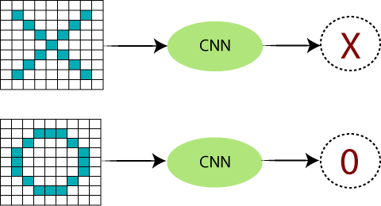
Figure 3.1: Convolutional neural network (CNN) phase-1 in action

These four shapes and the right side may represent X in certain more complicated circumstances; in such cases, they are only the consequences of the warped pictures. X and O's are presented in many ways here. The computer will have a hard time identifying it because of this. However, the objective is to convolve the incoming signal with the "image" baseline signal if it resembles prior pictures it has handled. After that, the subsequent layer receives the output signal. Think about the following diagram:
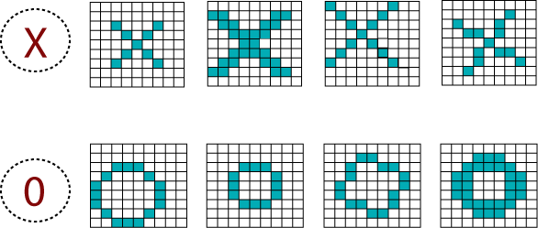

Figure 3.2: Neural Network Phase 2 Operation

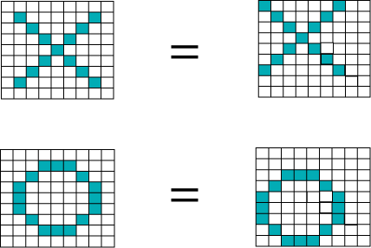

Figure 3.3: Convolutional neural network (CNN) phase 3 behavior

The numerical values stored in each pixel allow a computer to interpret images. Blue pixels will have a value of 1 in our case, whereas white pixels would have a value of -1. In our core binary classification, this is how we've implemented pixel differentiation.
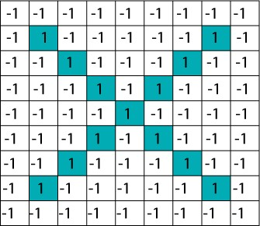

Figure 3.4: Working of CNN phase-4

When we use standard techniques to compare these two images, one is a proper image of X, and another is a distorted image of X. We found that the computer cannot classify the deformed image of X. It is compared with the proper representation of X. So when we add the pixel values of both images, we get something, so a computer cannot recognize whether it is anX or not.

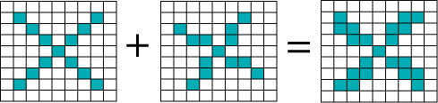

Figure 3.5: Working of CNN phase-5
Using convolutional neural networks (CNNs), we extract tiny regions of our picture and call them filters. Using the same area in two images, we were able to locate approximate feature matches. The more similar all of the picture matching algorithms are, the better CNN becomes. We have these filters; take the first one into consideration; it is a correct picture with a feature that is identical to that of the distorted image's component. Section by section, CNN compares the picture. Canny neural networks (CNNs) outperform whole-image matching algorithms when it comes to detecting similarities between pictures by locating rough matches in relative positions.

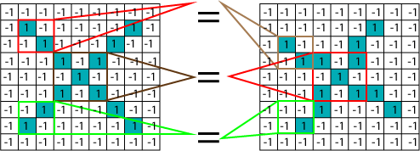

Figure 3.6: Working of CNN phase-6

3.2 Data Preprocessing

A few preprocessing procedures were performed for standardizing and prepare the photos before the model was trained. To ensure uniformity, every image was downsampled to 224 × 224. To make training more stable and convergent, the pixel values were standardized. Disease classifications were grouped into labels, which were subsequently codified into numbers. This data was then split into training and validation samples with most of them going in training to enable the model to learn representative patterns.

3.2.1 Image Augmentation

There were multiple augmentation techniques applied to counter dataset ceilings and overfitting. Techniques included rotations, flipping, zooming in, brightness adjustments, and noise application.Augmentation allows the dataset to have more variance. The model can learn how to spot diseases in various scenarios, creating a more accurate model. We used data augmentation on the preprocessed photos to expand our dataset and make our CNN model more generalizable. For every single one of these images, we used the following procedures:
- We randomly flipped the horizontal and vertical orientations of each picture with a chance of 0.5.
- To ensure uniformity, we rotated each picture at random from -10 to 10 degrees.
- Zooms at random: We used a slider from 0.8 to 1.2 to randomly zoom in on each picture.
- During training, we enhanced the data using the Keras Image Data Generator class. Without needing to save them to disk, we were able to create fresh pictures during training in real-time. During training, we used a batch size of 32 photos and produced 10 augmented images for every initial photograph in our dataset.
Our model's performance on verification set was enhanced, and overfitting was reduced, thanks to data augmentation. Additionally, our model became more resistant to changes in the input photos' lighting, orientation, and size as a result.

Chapter 4: Design and Architecture

4.1 Model Architecture
The project applies to a Convolutional Neural Network that is used to perform multiclass classification. CNN layers find visual features of the input images, and as we move along, we find shapes, textures and patterns associated with the symptoms of a disease. Once the features have been extracted, fully connected layers are used to interpret them and the images are grouped into one of the four disease categories. The architecture has a compactness in complexity and performance to provide effective training and prediction.
Convolutional neural networks (CNNs) are a kind of deep learning algorithm that works with input that is arranged in a grid. Convolutional neural networks (CNNs) are one of the best types of deep learning algorithms for processing input that is connected in time or space. Convolutional neural networks employ a series of convolutional layers to make the network more sophisticated, much like other forms of neural networks. Without convolutional layers, a CNN wouldn't be complete. To the right of this paragraph is a scaled-down version of a popular CNN design.

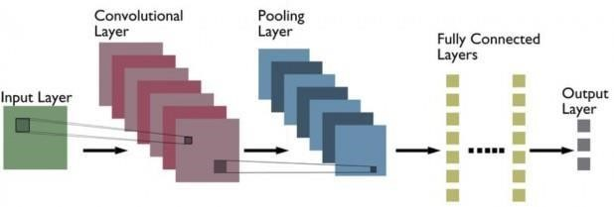
Fig
ure 4.1
:

Typical

architecture

of

CNN

We extracted features from our dataset of pictures of potato plant leaves before we trained our CNN model. For feature extraction, we turned to the VGG16 pre-trained model. The ImageNet dataset was used to train the widely-used pre-trained model VGG16, which has attained state-ofthe-art performance on several computer vision applications.
We used the convolutional layers that resulted from removing the VGG16 model's last classification layer to extract characteristics from photos of potato plant leaves. Next, we fed the last convolutional layer's output—which had been flattened—into our own fully linked layers. To boost the efficiency of our custom CNN model, we used the built-in VGG16 model for the extraction of features. We could use the model's ability to find high-level characteristics in photos because of this. We loaded the VGG16 model that had been trained and used the Keras Standard Deep Learning Library to get features from our dataset.. On top of that, we trained our own CNN model using the retrieved features by constructing it in Keras. In the last part, we covered the specifics of how our CNN model was implemented.

4.2 Model Development and Deployment
In order to train the model, the TensorFlow and Keras platforms were used.Adam optimizer was chosen due to its adaptive learning nature, and the model was trained in various epochs to permit adequate learning. After the training stage, deploying the model was done with FastAPI as this was the backend framework that was able to receive image uploads and make predictions. Using the FastAPI endpoint, the user can input an image, which is fed through the model, and the classification of the image is given .
The web interface is built on React.js to make it easy to use especially for the farmers and other general users. The interface enables the user to upload leaf images on their device and get the results of the classification immediately. Such a structure allows detecting diseases in real-time and makes AI technology more available to the agricultural community.

4.3 Experimental Setup
The user chooses a picture via the web app while the system is running. Prior to being fed into the trained model, the picture is preprocessed in the FastAPI backend. A crystal-clear forecast is subsequently shown on the user experience by the system. In order to get a full picture of how well the system worked, measures including precision, loss, matrix of creative confusion, precision, recollection, and F1-score were used to evaluate the model.

Chapter 5: Implementation

The objectives of the suggested detection system for apple leaf disease are to implement a deployed neural net model that can interact with real world applications when the proposed deep learning serves as an operational application. Combining the model together with the backend deployment and frontend interaction in such a way that it is one complete system making predictions through API calls.. To make the implementation process effective, efficient, and user-friendly, it was conducted with the help of both deep learning frameworks and modern web technologies.
The trained Convolutional Neural Network (CNN) model, created with the help of TensorFlow and Keras is the core of the system. Upon successful training and validation the model was saved in an appropriate format so that the model can be deployed. Saved model stores learned weights and architecture which enables it to classify new input images without retraining. The model was installed in the backend environment (during implementation) where it acts as the system prediction engine.
To develop the back-end, FastAPI was chosen based on its high performance, simplicity, and capacity to take asynchronous requests. FastAPI allows building RESTful APIs with the help of which the model can communicate with other applications. A RESTful endpoint that would receive pictures uploaded by users was created. Once an image is uploaded, it is processed in the same way that it would be processed during the training process, such as resizing to 224x224 pixels, normalization and conversion into a format compatible with the model. After preprocessing, the image is fed into the CNN model that produces a prediction that belongs to one of four classes: Healthy, Apple Scab, Black Rot, or Cedar Apple Rust. The result of the prediction is subsequently sent back to the user in a formatted manner.
React.js was used to build the frontend of the system to offer a user-friendly and easy-touse interface. The web application will enable users to post the images of apple leaves on their devices. The interface has been made user friendly so that even non-technical users like farmers can easily communicate with the system. After uploading an image, it is sent to FastAPI backend using HTTP requests. The backend processes the image and gives out the predicted output which is displayed on the interface in real time.
The frontend and backend are integrated to provide efficient communication and a quick response. This design allows the system to be a full pipeline, beginning with user input and ending with final prediction output. Scalability is also possible with FastAPI, i.e., the system can be deployed on local servers or cloud services, based on the needs of the user. To create a reliable performance, the system was tested with hidden images in order to check that the system has the capability to predict in real time. The deployment showed that the system is capable of effectively handling images and providing true results in a relatively small time period. Also, error handling controls were introduced to handle invalid inputs and provide stability to the system.
In general, the application is effective in closing the theoretical model formulation and practice gap. The system uses deep learning and web-based technologies that can offer an effective solution to automated plant disease detection. This application will not only increase access, but it will also assist farmers to make timely and informed decisions, which will result in increased agriculture productivity.

Chapter 6: Result and Discussion

6.1 Model Training and Validation

For the identification of the features in photos taken for plant leaves, an Apple Leaf Disease Detection system has been suggested using CNN architecture. We split our data into testing, training and validation groups very cautiously to ensure that the models were established fairly while also not overfitting. While training was weighted on the network adjustments, validation set further fine tuned hyperparameters such as learning rate and number – epochs batch size. The model has exhibited a consistent convergence tendency throughout training, with the accuracy of both the sets for validation and training going up with each successive epoch.
The fact that training and validation curves are close to each other implies that the model was able to generalize to unseen data. The introduction of Linear Unit Functions (Rectified) (relu) aided in solving the problem of vanishing gradient by allowing quicker convergence and increased learning efficiency as shown in Figure 13 which displays the behavioral pattern of relu and pooling layers in CNN’s in a graphic form. The use of pooling layers helped to reduce the spatial dimensions, minimize the complexity of the computations and select the most significant features among the convolutional layers, which also made the model even more robust. Spatial dimensionality reduction was accomplished by using pooling layers, computational complexity was reduced and relevant features of the convolutional layers were preserved.

6.1.1 The RELU and pooling layers in a CNN

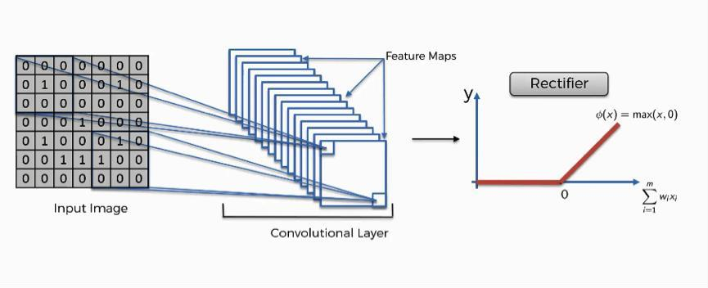
Figure 6.1: Relational and pooling layer graphical behavior

6.2 Performance Evaluation and Comparison
We assessed the CNN model trained using a set of measurable parameters, including precision, recall, accuracy, and F1-score. In most of the experiments, the model's average classification accuracy was roughly 99 percent, with accuracy levels ranging from 95 percent to 100 percent across different illness groups. Early Blight detection rate was 98 per cent and this is a good indicator that the model can detect disease signs early.
The model was also tested on other test data set that was not used for the training and validation to ensure reliability. Good performance in this independent data set verifies the strength of the model and its appropriateness in the real-world agricultural applications. Confusion matrices have been used to represent the classification performance and to get an idea of the true positives, true negatives, false positives, and false negatives of each disease class. The proposed model was also compared with the present state of the art, in the domain of plant disease detection, to establish the similarities. The results of these findings showed that the presented CNN-based system either had the same accuracy and stability as most of the systems available or had more. This comparative study provides evidence of the effectiveness of the selected architecture, feature extraction strategy and the training method.

6.3 Visual Analysis and System Outputs
The visual analysis was important in interpreting the inner workings of the model as well as the end predictions. The visual action of RELU and pooling layers is represented in Figure 13 that showcases the advantage of non-linearity and spatial down-sampling in enhancing feature extraction and efficiency of learning. Figure 14 provides the individual graphical representation of the RELU activation function, which has been shown to remove negative activations and reduce model convergence time.

6.3.1 The CNN graph displaying the RELU

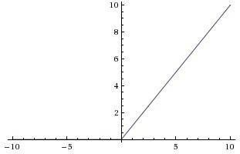
Figure 6.2: Visual depiction of RELU

6.3.2 Output of the images given to browser

Apple Scab:
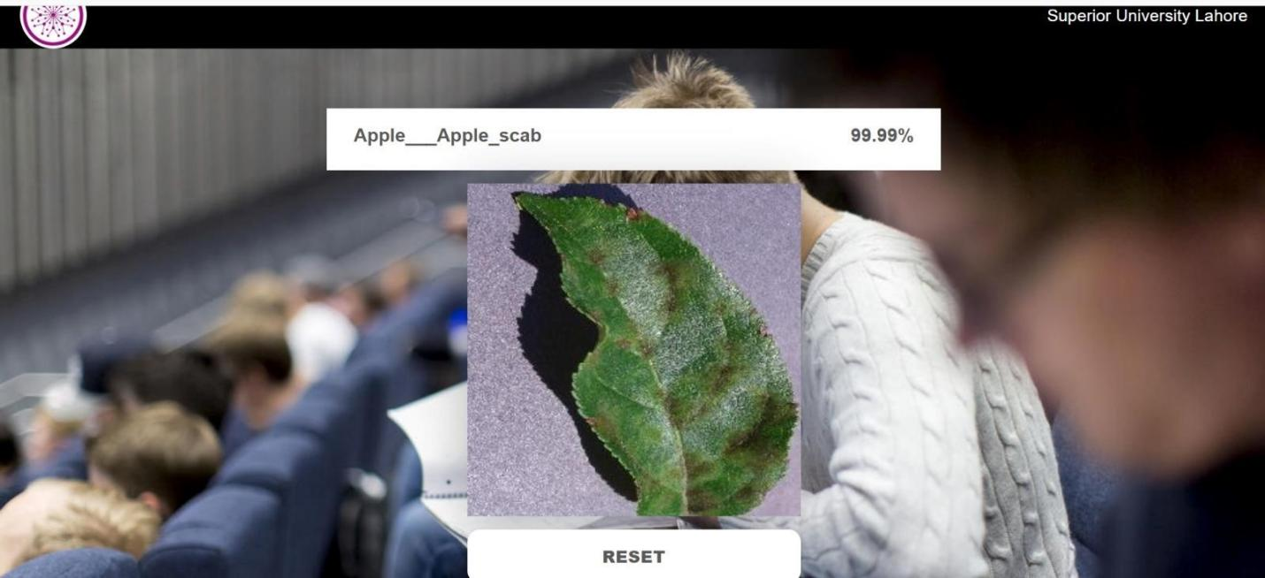

Figure 6.3: Apple Scab picture output shown on the browser

Black root:
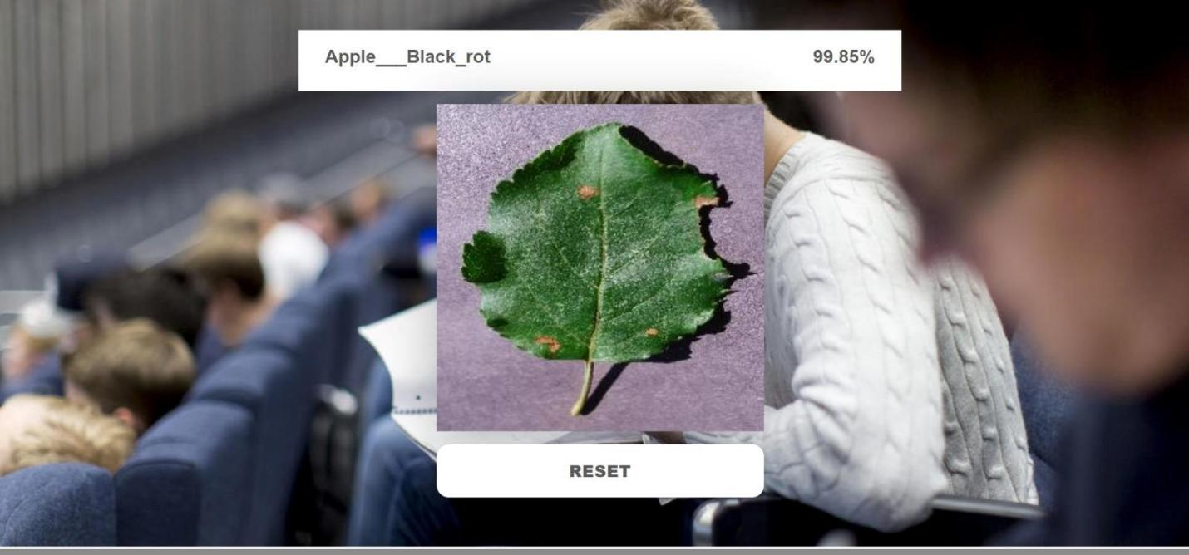

Figure 6.4: Black root picture output shown in the browser

Healthy:

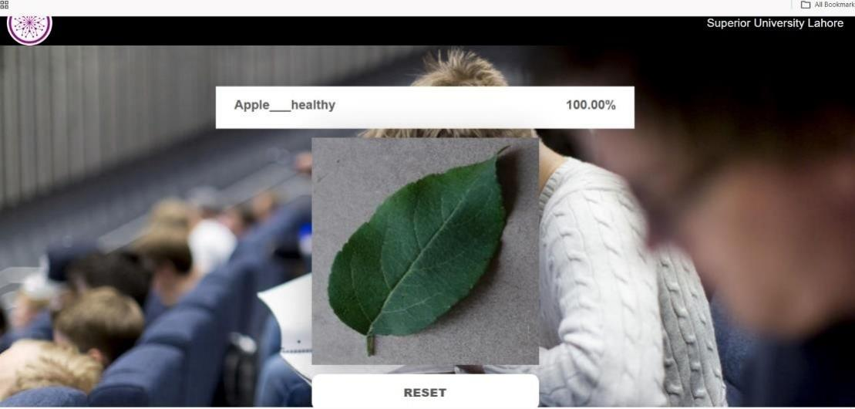
Figure 6.5:
Pictures of healthy leaves shown on a web browser

Figure 6.5: Pictures of healthy leaves shown on a web browser

Besides internal visualizations, the system outputs were also shown in a browser-based interface which was made with Fast API. Outputs of sample predictions of Early Blight, Late Blight, and Healthy leaf images are depicted in Figure 15, 16 and 17, respectively. These values affirm the fact that the system can correctly categorize the input leaf images and give useful visual feedback and can be used effectively by farmers and agricultural professionals.
Experimental findings point to the fact that the suggested system is very efficient in automated detection of plant leaves disease. The model has one of the greatest strengths in its high accuracy and their ability to perform the same in various disease categories. Deep learning enabled the system to automatically learn the complicated features that are hard to extract with the conventional image processing techniques. Although there were strengths, some limitations were witnessed. The model could perform differently in condition of images taken in extreme lighting or the background not included in the training set. On top of that, the system is at present restricted to a set of apple diseases. One interesting finding was that the visual features of disease classes were highly represented in the dataset, which explained why the accuracy of the individual disease classes was exceptionally high. Overall, the findings confirm the efficacy of CNN-based methods in agricultural diagnostics and emphasize the possibilities of the implementation of this sort of system in the field of real farming.

Chapter 7: Conclusion and future work

7.1 Summary of Findings
The proposed study was able to design, deploy and test a deep learning-based Plant Leaf Disease Detection system that can effectively detect plant leaves through image classification.The accuracy of the proposed model was about 99% and the accuracy of detecting individual diseases was up to 98%. The experimental results and the evaluation metrics prove the fact that the system works reliably on unseen data, and it can be used in the agricultural domain.

7.2 Contributions of the Study
The major developments made by the present study are the creation of effective CNN architecture to detect plant diseases, the incorporation of advanced development tools like Python-based ides to develop the model, and the application of the trained model to predict plant disease in real-time with the help of fast Api. The paper also offers an organized performance analysis model based on standard measures, which may be used as a point of reference in further research.

7.3 Limitations
Even though the proposed system was very accurate, it has a number of limitations. The training and evaluation sample was not large and diverse, which can limit the model in terms of its capability to apply to all types of crops and environmental factors. Furthermore, there is no additional contextual information, e.g. weather, soil quality and information derived from sensors are not incorporated in the system.

7.4 Future Research Recommendation

The subject can be further expanded in future research for more crops, diseases, and environment. Future enhancements to the detection accuracy may be based on more complex deep learning architectures, such as deeper CNN models or hybrid architectures. For limited data training, the use of a pretrained model for transfer learning can help to save training time and help reduce error rates. Other enhancements may be integrated as real-time tracking systems, field applications and alerts to warn farmers to look for possible outbreaks. Application of explainable artificial intelligence (XAI) methods would also improve transparency and trust to users. Overall, the role of the system can be enhanced in the future to foster sustainable food security and agriculture

References
- Bock, C. H., Barbedo, J. G., Del Ponte, E. M., Bohnenkamp, D., & Mahlein, A. K. (2020). From visual estimates to fully automated sensor-based measurements of plant disease severity: status and challenges for improving accuracy. Phytopathology Research, 2(1), 9.
- Zhao, Y., & Xie, Q. (2025). Review of Deep Learning Applications for Detecting Special Components in Agricultural Products. Computers, 14(8), 309.
- Tanwar, S., Kumari, A., Vekaria, D., Kumar, N., & Sharma, R. (2022). An AI-based disease detection and prevention scheme for COVID-19. Computers and Electrical Engineering, 103, 108352.
- Ahmed, S. F., Alam, M. S. B., Hassan, M., Rozbu, M. R., Ishtiak, T., Rafa, N., ... & Gandomi, A. H. (2023). Deep learning modelling techniques: current progress, applications, advantages, and challenges. Artificial Intelligence Review, 56(11), 1352113617.
- Brown, J. M., Campbell, J. P., Beers, A., Chang, K., Ostmo, S., Chan, R. P., ... & Imaging and Informatics in Retinopathy of Prematurity (i-ROP) Research Consortium. (2018). Automated diagnosis of plus disease in retinopathy of prematurity using deep convolutional neural networks. JAMA ophthalmology, 136(7), 803-810.
- Li, C., Yang, Y., Liang, H., & Wu, B. (2021). Transfer learning for establishment of recognition of COVID-19 on CT imaging using small-sized training datasets. Knowledgebased systems, 218, 106849.
- Abdulaal, A., Patel, A., Charani, E., Denny, S., Mughal, N., & Moore, L. (2020). Prognostic modeling of COVID-19 using artificial intelligence in the United Kingdom: model development and validation. Journal of Medical Internet Research, 22(8), e20259.
- Sow, S., Ranjan, S., Seleiman, M., Alkharabsheh, H., Kumar, M., Kumar, N., ... & Wasonga, D. (2024). Artificial intelligence for maximizing agricultural input use efficiency: exploring nutrient, water and weed management strategies. Phyton, 93(7), 1569.
- Pappula‐Reddy, S. P., Kumar, S., Bi, M. H., Singh, A., Shrivastav, A. K., Siddique, K. H., & Chellapilla, B. (2025). Prediction of Traits Using Artificial Intelligence Machine Learning. Custom‐Designed Crop Breeding: Advanced Technologies, 1, 333-358.
- Mitchell, T. M., Carbonell, J. G., & Michalski, R. S. (Eds.). (1986). Machine learning: a guide to current research (Vol. 12). Springer Science & Business Media.
- He, K., Zhang, X., Ren, S., & Sun, J. (2016). Deep residual learning for image recognition. In Proceedings of the IEEE conference on computer vision and pattern recognition (pp. 770-778).
- Balafas, V., Karantoumanis, E., Louta, M., & Ploskas, N. (2023). Machine learning and deep learning for plant disease classification and detection. IEEE Access, 11, 114352114377.
- Ferentinos, K. P. (2018). Deep learning models for plant disease detection and diagnosis. Computers and electronics in agriculture, 145, 311-318.
- Wang, Y. (2020). Gaps in real-time agricultural AI systems. 15–27. As provided in your literature table.
- Sahu, P., Singh, A. P., Chug, A., & Singh, D. (2022). A systematic literature review of machine learning techniques deployed in agriculture: A case study of banana crop. IEEE access, 10, 87333-87360.
- Shorten, C., & Khoshgoftaar, T. M. (2019). A survey on image data augmentation for deep learning. Journal of big data, 6(1), 1-48.Goodfellow, I. (2016). Deep Learning textbook.
- Hosni, M., Carrillo de Gea, J. M., Idri, A., El Bajta, M., Fernandez Aleman, J. L., GarciaMateos, G., & Abnane, I. (2021). A systematic mapping study for ensemble classification methods in cardiovascular disease. Artificial Intelligence Review, 54(4), 2827-2861.
- Noronha, S. S., Mehta, M. A., Garg, D., Kotecha, K., & Abraham, A. (2023). Deep learning-based dermatological condition detection: A systematic review with recent methods, datasets, challenges, and future directions. IEEE Access, 11, 140348-140381.
- Shorten, C., Khoshgoftaar, T. M., & Furht, B. (2021). Text data augmentation for deep learning. Journal of big Data, 8(1), 101.
- Araújoa, A. L. D., Moraesb, M. C., Pérez-de-Oliveiraa, M. E., da Silvab, V. M., Siracusaa, C. S., Pedrosoa, C. M., ... & Santos-Silvaa, A. R. 2.4 Artigo: Machine Learning for the prediction of toxicities from head and neck cancer treatment: a systematic review with meta-analysis. MACHINE LEARNING APLICADA ÀS INVESTIGAÇÕES NOS CAMPOS DA ESTOMATOLOGIA E DA PATOLOGIA ORAL E MAXILOFACIAL, 77.
- Vengadesh, S., Chinna, P. R., & Aravindaraj, K. (2025). A bibliometric analysis of research trends in goods transportation using the scopus database. Business Perspectives and Research, 13(3), 347-368.
- Kumar, D., & Kukreja, V. (2022). Deep learning in wheat diseases classification: A systematic review. Multimedia Tools and Applications, 81(7), 10143-10187.
- Pi, R., Guo, L., Yang, J., LENG, J., Lu, Y., & Yan, F. Knowledge Management in the Era of Aigc: Review of Domain Knowledge Graph. Available at SSRN 5093869.
- Khan, M. A. M., Kee, S. H., Pathan, A. S. K., & Nahid, A. A. (2023). Image processing techniques for concrete crack detection: A scientometrics literature review. Remote sensing, 15(9), 2400.
- Altini, N., De Giosa, G., Fragasso, N., Coscia, C., Sibilano, E., Prencipe, B., ... & Bevilacqua, V. (2021, June). Segmentation and identification of vertebrae in CT scans using CNN, k-means clustering and k-NN. In Informatics (Vol. 8, No. 2, p. 40). MDPI.
- Maharana, K., Mondal, S., & Nemade, B. (2022). A review: Data pre-processing and data augmentation techniques. Global Transitions Proceedings, 3(1), 91-99.
- Farady, I., Lin, C. Y., & Chang, M. C. (2024). PreAugNet: improve data augmentation for industrial defect classification with small-scale training data. Journal of Intelligent Manufacturing, 35(3), 1233-1246.
- de la Rosa, F. L., Moreno-Salvador, L., Gómez-Sirvent, J. L., Morales, R., Sánchez-Reolid, R., & Fernández-Caballero, A. (2024, May). Improved surface defect classification from a simple convolutional neural network by image preprocessing and data augmentation. In International Work-Conference on the Interplay Between Natural and Artificial Computation (pp. 23-32). Cham: Springer Nature Switzerland.
- Chokchaithanakul, W., Punyabukkana, P., & Chuangsuwanich, E. (2022). Adaptive image preprocessing and augmentation for tuberculosis screening on out-of-domain chest X-ray dataset. IEEE Access, 10, 132144-132152.
- Barshooi, A. H., & Amirkhani, A. (2022). A novel data augmentation based on Gabor filter and convolutional deep learning for improving the classification of COVID-19 chest XRay images. Biomedical Signal Processing and Control, 72, 103326.
- Goceri, E. (2023). Medical image data augmentation: techniques, comparisons and interpretations. Artificial intelligence review, 56(11), 12561-12605.
- DeVries, T., & Taylor, G. W. (2017). Dataset augmentation in feature space. arXiv preprint arXiv:1702.05538.
- Abeysinghe, A., Tohmuang, S., Davy, J. L., & Fard, M. (2023). Data augmentation on convolutional neural networks to classify mechanical noise. Applied Acoustics, 203, 109209.
- Kozina, A., & Pikus, M. (2025, October). A Comprehensive Review of Data Augmentation Methods for Support Business Processes Using Machine Learning and Deep Learning. In European Conference on Artificial Intelligence (pp. 66-79). Cham: Springer Nature Switzerland.
- Meister, S., Möller, N., Stüve, J., & Groves, R. M. (2021). Synthetic image data augmentation for fibre layup inspection processes: Techniques to enhance the data set. Journal of Intelligent Manufacturing, 32(6), 1767-1789.
- Akrout, M., Gyepesi, B., Holló, P., Poór, A., Kincső, B., Solis, S., ... & Fazekas, I. (2023, October). Diffusion-based data augmentation for skin disease classification: Impact across original medical datasets to fully synthetic images. In International conference on medical image computing and computer-assisted intervention (pp. 99-109). Cham: Springer Nature Switzerland.
- Elder, H., & Hokamp, C. (2018). Generating high-quality surface realizations using data augmentation and factored sequence models. arXiv preprint arXiv:1805.07731.
- Kaur, S., Aggarwal, H., & Rani, R. (2021). Diagnosis of Parkinson’s disease using deep
CNN with transfer learning and data augmentation. Multimedia Tools and Applications, 80(7), 10113-10139.
- Eshun, R. B., Bikdash, M., & Islam, A. K. (2024). A deep convolutional neural network for the classification of imbalanced breast cancer dataset. Healthcare Analytics, 5, 100330.
- Lorenzo, P. R., Nalepa, J., Bobek-Billewicz, B., Wawrzyniak, P., Mrukwa, G., Kawulok, M., ... & Hayball, M. P. (2019). Segmenting brain tumors from FLAIR MRI using fully convolutional neural networks. Computer methods and programs in biomedicine, 176, 135-148.
- Zhang, X., & Wu, R. (2016, March). Fast depth image denoising and enhancement using a deep convolutional network. In 2016 IEEE International Conference on Acoustics, Speech and Signal Processing (ICASSP) (pp. 2499-2503). IEEE.
- Kalpana, G., Deepa, N., & Dhinakaran, D. (2025). Advanced image preprocessing and context-aware spatial decomposition for enhanced breast cancer segmentation. MethodsX, 14, 103224.
- Aamir, M., Rahman, Z., Abro, W. A., Bhatti, U. A., Dayo, Z. A., & Ishfaq, M. (2023). Brain tumor classification utilizing deep features derived from high-quality regions in MRI images. Biomedical Signal Processing and Control, 85, 104988.
- Wiese, L., & Höltje, D. (2021, June). NNCompare: a framework for dataset selection, data augmentation and comparison of different neural networks for medical image analysis. In Proceedings of the Fifth Workshop on Data Management for End-To-End Machine Learning (pp. 1-7).
- Jose, J., Gautam, N., Tiwari, M., Tiwari, T., Suresh, A., Sundararaj, V., & MR, R. (2021). An image quality enhancement scheme employing adolescent identity search algorithm in the NSST domain for multimodal medical image fusion. Biomedical Signal Processing and Control, 66, 102480.
- Verma, G., Taluja, C., & Saxena, A. K. (2019, November). Vision based detection and classification of disease on rice crops using convolutional neural network. In 2019 international conference on cutting-edge Technologies in Engineering (icon-cute) (pp. 14). IEEE.
- Shah, N., & Jain, S. (2019, February). Detection of disease in cotton leaf using artificial neural network. In 2019 amity international conference on artificial intelligence (AICAI) (pp. 473-476). IEEE.
- Kumari, C. U., Prasad, S. J., & Mounika, G. (2019, March). Leaf disease detection: feature extraction with K-means clustering and classification with ANN. In 2019 3rd international conference on computing methodologies and communication (ICCMC) (pp. 1095-1098). IEEE.
- Sharath, D. M., Kumar, S. A., Rohan, M. G., & Prathap, C. (2019, April). Image based plant disease detection in pomegranate plant for bacterial blight. In 2019 international conference on communication and signal processing (ICCSP) (pp. 0645-0649). IEEE.
- Lubis, A. H., Wardani, D. K., Pradana, M. G., Sahputra, I., & Ula, M. Optimizing VGG16 for Accurate Pest Identification in Oil Palm: A Comparative Study of Fine-Tuning Techniques.
- Lubis, A. H., Wardani, D. K., & Pradana, M. G. (2025). Res-DSCBAM: A Comprehensive Framework for Efficient Oil Palm Pest Classification Using Integrated resnet50, Depthwise Separable Convolution, and Convolutional Block Attention Module. IAENG International Journal of Computer Science, 52(1).
- Kumar, M., Gupta, P., & Madhav, P. (2020, June). Disease detection in coffee plants using convolutional neural network. In 2020 5th International Conference on Communication and Electronics Systems (ICCES) (pp. 755-760). IEEE.
- Francis, J., & Anoop, B. K. (2016, March). Identification of leaf diseases in pepper plants using soft computing techniques. In 2016 conference on emerging devices and smart systems (ICEDSS) (pp. 168-173). IEEE.

.

